Leveraging Sentiment Analysis for maximizing customer satisfaction: An Industrial Engineering Approach

Leveraging Sentiment Analysis for maximizing customer satisfaction: An Industrial Engineering Approach 1
1. Introduction 3
2. Literature Review 3
3. Methodology 4
Problem Identification and Scope 4
Exploratory Data Analysis 4
Sentiment Analysis 4
Topic Classification 5
Optimization of Customer Satisfaction 5
Insights and Actionable Recommendations 5
4. Data Collection and Preprocessing 5
5. Results 6
Overall analysis 6
1. What are the percentages for each country in the data? 6
2. What are the attracts we are getting customers? 7
3. What is the distribution of sentiments among our customers? 8
4. Why do people choose Dresden? 9
5. Recommendations on products 10
6. What amount of overall data is giving certain recommendations? 11
7. What is the amount of overall data in different satisfaction levels? 12
9. Satisfaction level at each level of each topic comment 13
Australia 15
1. What are the main reasons people choose Dresden in Australia? 15
2. What are the main topics in the comments in Australia? 16
3. What are the recommendation levels per level in Australia? 17
4. Topics by satisfaction levels in Australia? 18
5. What are the sentiment levels per product in Australia? 19
6. What are the main ways people find Dresden in Australia? 20
CANADA 22
1. What are the main reasons people favor Dresden in Canada? 22
2. What are the main topics in Canada's comments? 23
3. What is the percentage sentiment of each topic from the comment section? 24
4. What are the main ways people are finding Dresden in Canada? 25
5. What are the main topics based on each level of recommendation? 26
6. What are the main topics based on each level of satisfaction? 27
NEW ZEALAND 28
1. What are the main topics in each level of recommendation? 28
2. What is the contribution to the sentiment of each topic? 29
3. What are the main topics discussed in new zealand? 30
Discussion 31
Top most appearing words in negative comments 31
Top most appearing words in Positive comments 32
Negative comments 33
INTEGER OPTIMIZATION USING GUROBI 33
Recommendations 36
7. Limitations and Future Work 37
8. Conclusion 37
keywords 38

1. Introduction
Dresden Optics is an eyeglass and eye prescriptive company that helps in providing sustainable glasses for people both for medical and recreational purposes. This project aims to analyze feedback from the customers and use those insights to optimize resources for maximum customer satisfaction.

2. Literature Review
After making thorough research on the sentiment and topics of the customers it became apparent that the structure of the survey is very important for the best output possible, moreover, making variety in the options can give space for customers to properly express their feelings towards the company.
Sentimental analysis and topic classification are both very good research methods however it was decided that we can take an industrial engineering twist to it by making another section solely for the optimization of customer satisfaction by giving weights to necessary topics and then using integer optimization model to see what topic should be prioritized in other to maximize customer satisfaction.

3. Methodology
In this section we will discuss step by step the methods we used in other to complete this project:

Problem Identification and Scope
At the outset of the project, the primary goal is to enhance customer satisfaction. This phase involves a thorough understanding of the company services provided and the data needed to continue this analysis.

Data Collection and Preprocessing
Effective data collection is essential for obtaining a comprehensive understanding of customer interactions and feedback. Data may be sourced from various channels such as customer reviews, surveys, social media, and support tickets. Once collected, the data undergoes rigorous preprocessing, including cleaning, deduplication, and standardization. This phase ensures that the data is accurate, consistent, and ready for analysis.

Exploratory Data Analysis
Exploratory data analysis (EDA) involves comprehensively examining the collected data. Visualization techniques and statistical methods are applied to uncover patterns, trends, outliers, and relationships within the data. EDA helps identify potential insights and areas of focus for subsequent analysis steps.

Sentiment Analysis
Sentiment analysis entails the use of natural language processing techniques to determine the sentiment expressed in customer comments. Each comment is classified as positive, neutral, or negative based on the emotional tone conveyed. This step enables the quantification of customer sentiment, providing insights into overall satisfaction levels and identifying areas that need improvement.

Topic Classification
In topic classification, the focus shifts to understanding the main themes or topics discussed in customer comments. Text mining techniques, such as topic modeling, categorize comments into distinct topics. This allows for granular analysis of customer feedback, highlighting both positive aspects that lead to satisfaction and pain points that result in dissatisfaction.

Optimization of Customer Satisfaction
With sentiments and topics identified, the optimization phase aims to improve customer satisfaction systematically. Each topic is considered a variable, and optimization techniques are applied to allocate resources effectively. Constraints related to company resources, budgets, and operational capabilities are factored in. The goal is to maximize positive sentiment and minimize negative sentiment across different regions and the entire company, thereby enhancing overall customer satisfaction.

Insights and Actionable Recommendations
Based on the findings from sentiment analysis, topic classification, and optimization, meaningful insights are extracted. These insights drive the formulation of actionable recommendations for the company. These recommendations may include strategic changes, process improvements, product enhancements, or communication strategies aimed at addressing specific customer concerns and improving overall satisfaction.

4. Data Collection and Preprocessing
Data was collected from surveys and Google reviews. The data was then normalized to fit into the following columns.
1. 'Id': Unique id given to each survey or Google review.
2. 'Location': unique id given to each shop location.
3. 'Country': where was the survey filled?
4. 'Where did you hear about us?': to get information on how the name Dresden is spreading around.
5. 'Why did you shop at Dresden?': information on why customers decided to shop at Dresden over other alternatives.
6. 'comments': The main text that reflects the customer's thoughts.
7. 'Satisfaction level’: How well was the customer satisfied?
8. 'How likely are you to recommend?’: how likely will customers recommend Dresden?

5. Results
In this section, we will look at the data from two perspectives firstly we look at an overall level then we drill down to the three specific locations and we gain insights from this.

Overall analysis

1. What are the percentages for each country in the data?
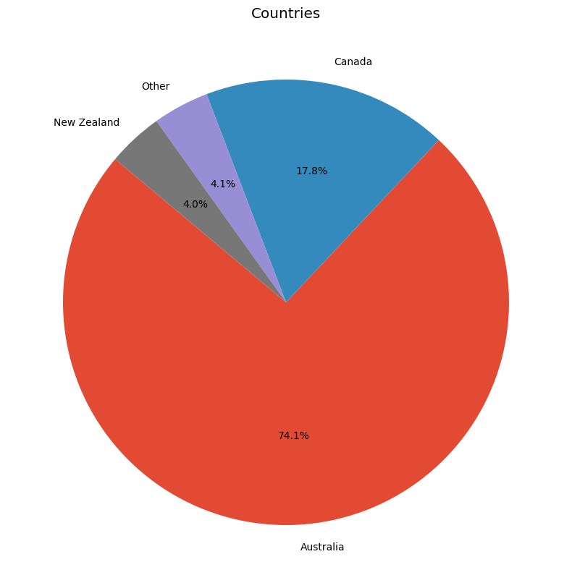
we can see that Australia is our main audience and then Canada and new zealand respectively.

2. What are attracting we are getting customers?
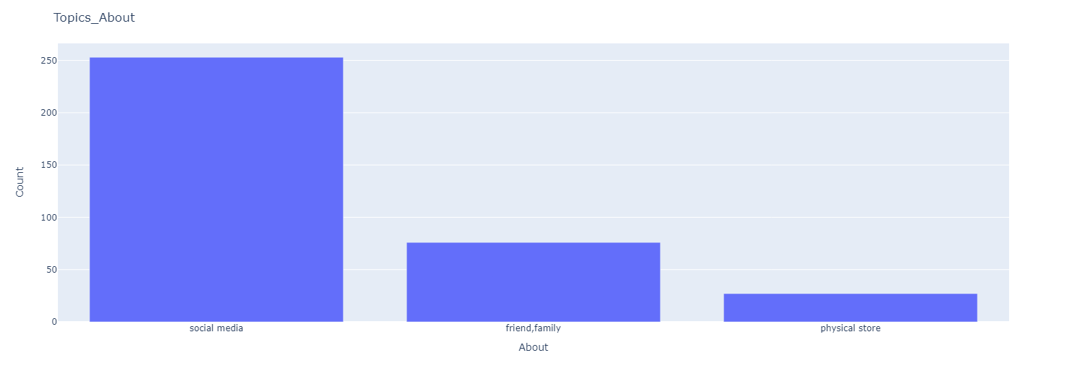
From this we can see that most of our customers discover us online, however, we also have a considerate amount who discover us from word of mouth.

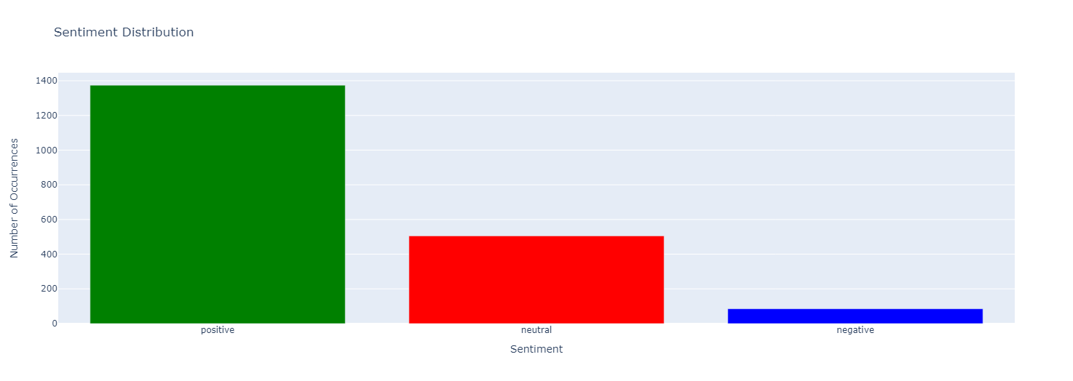
3. What is the distribution of sentiments among our customers?

4. Why do people choose Dresden?

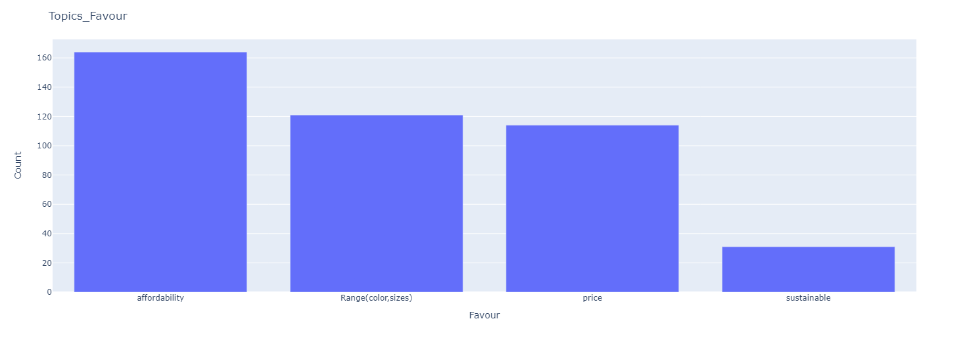

5. Recommendations on products
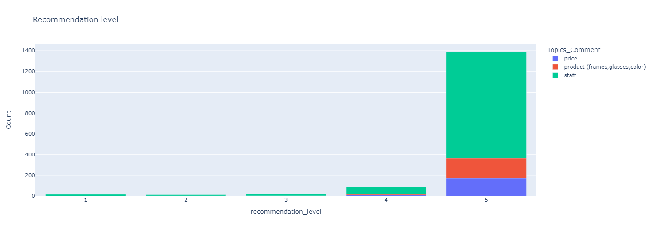
In this case, we look at each level of recommendation and we try to understand those recommending a certain level on what topics encourage them to recommend the most.

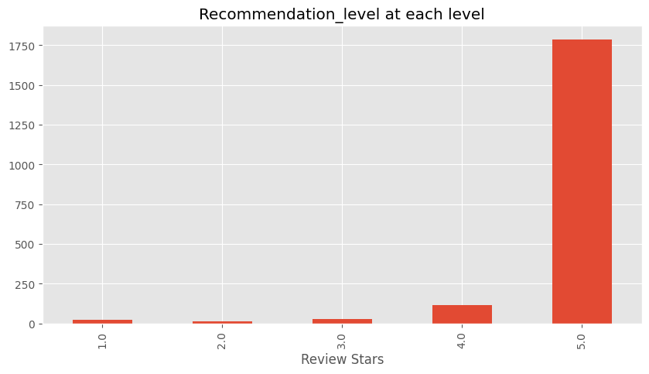
6. What amount of overall data is giving certain recommendations?

7. What is the amount of overall data in different satisfaction levels?
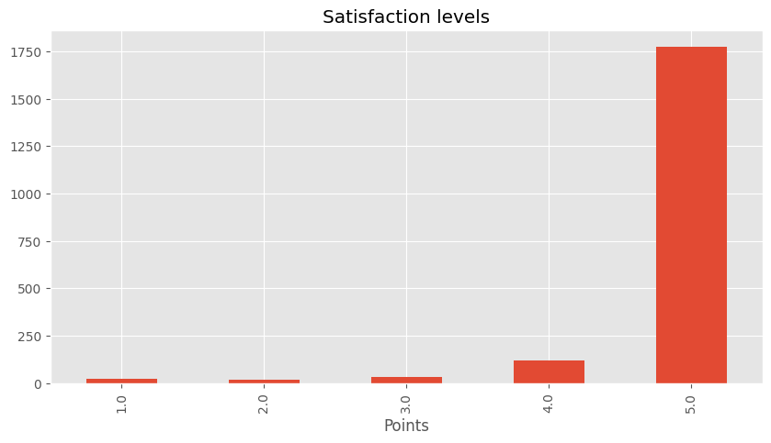

7.

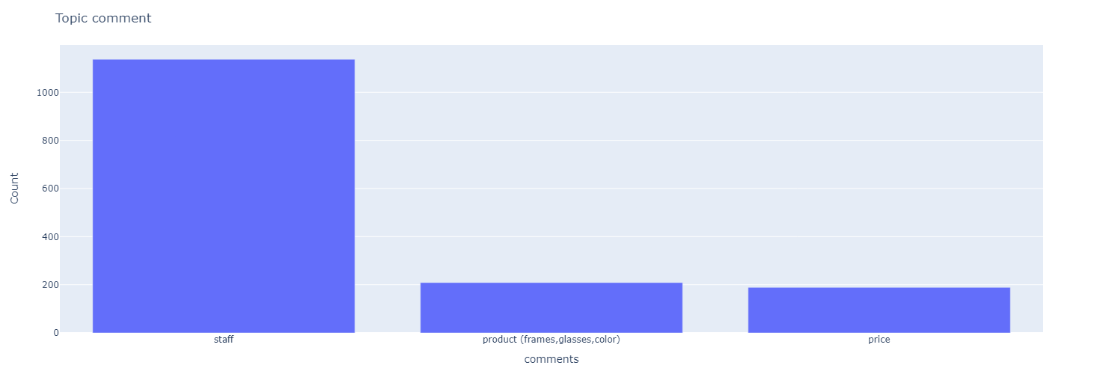

9. Satisfaction level at each level of each topic comment

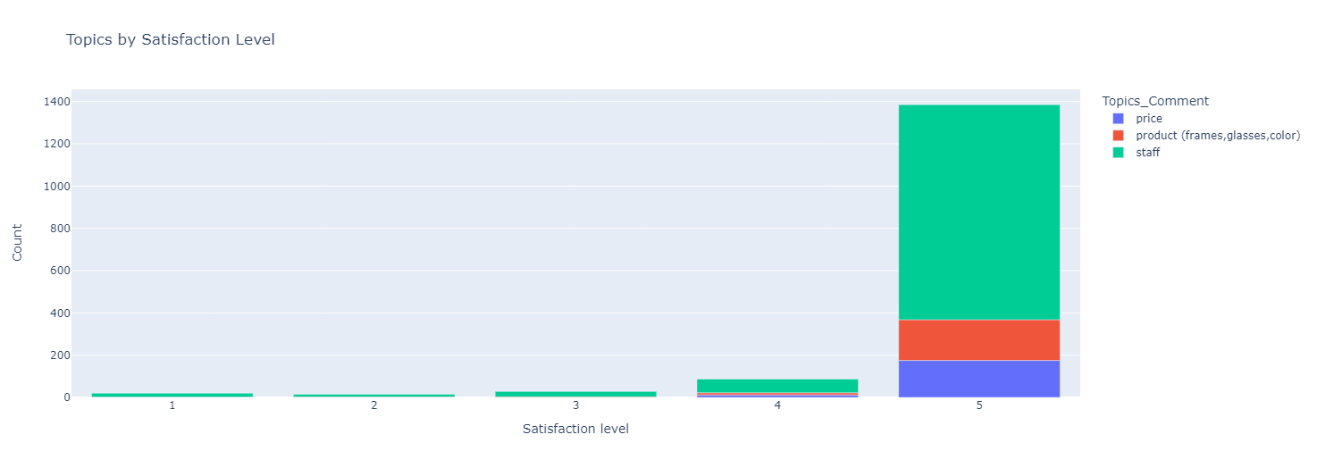

10. What are the main topics in the comments?

Australia
With a more drilled-down approach, we look at Australia

What are the main reasons people choose Dresden in Australia?
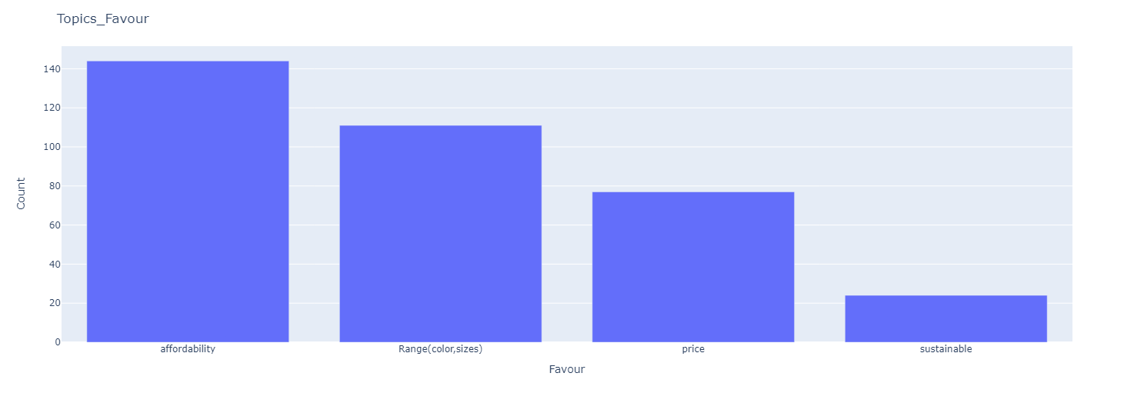

What are the main topics in the comments in Australia?

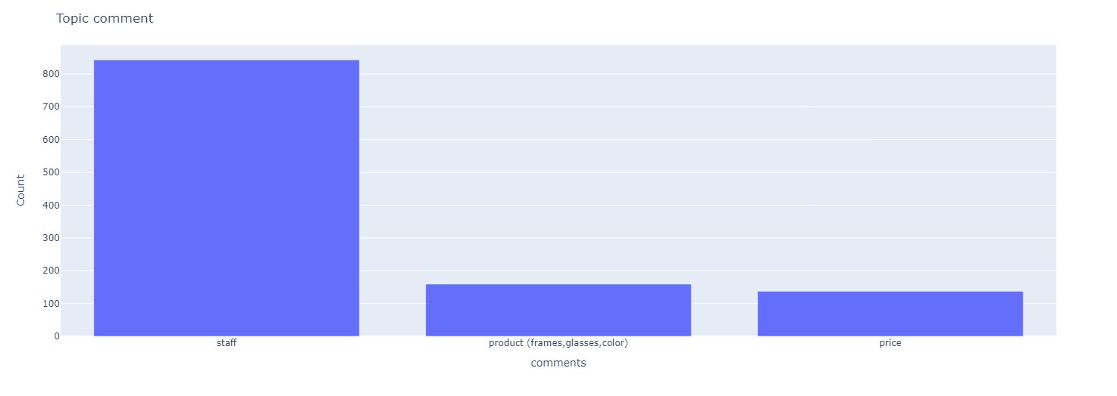

What are the recommendation levels per level in Australia?

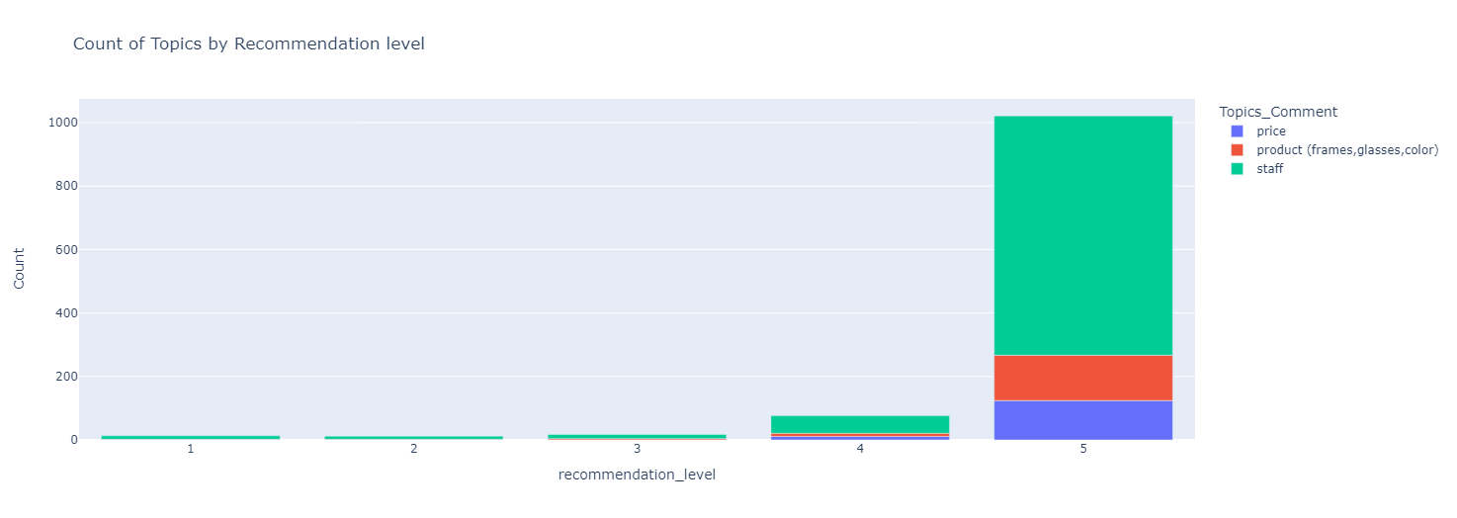

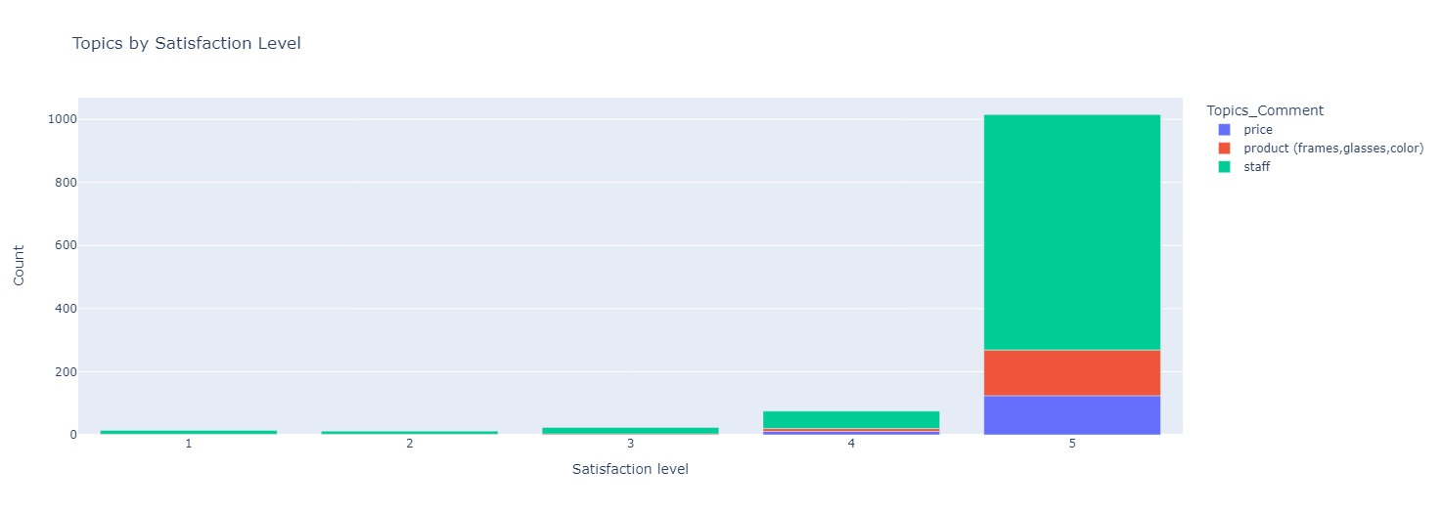
Topics by satisfaction levels in Australia?

What are the sentiment levels per product in Australia?

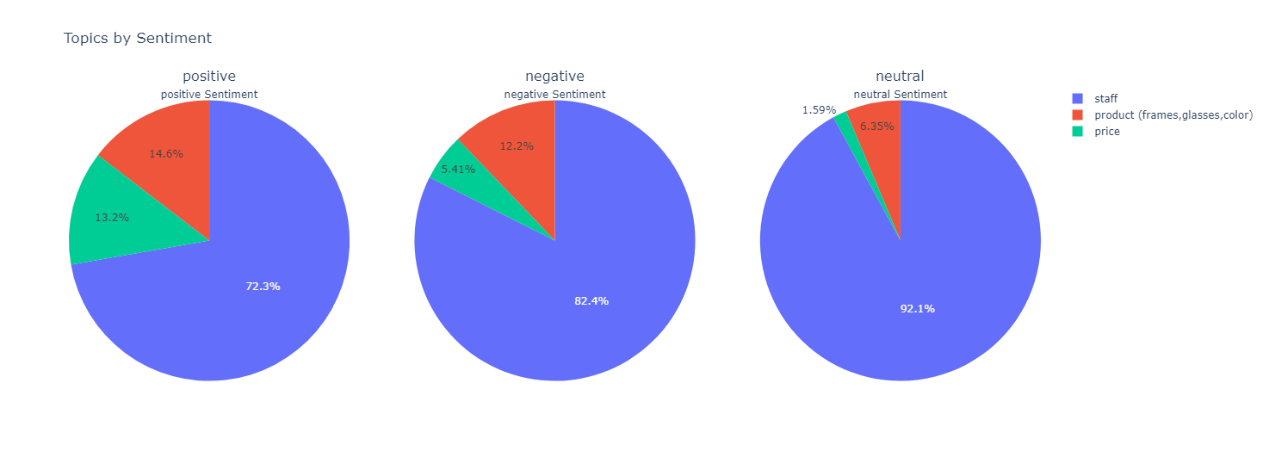

What are the main ways people find Dresden in Australia?

CANADA

What are the main reasons people favor Dresden in Canada?

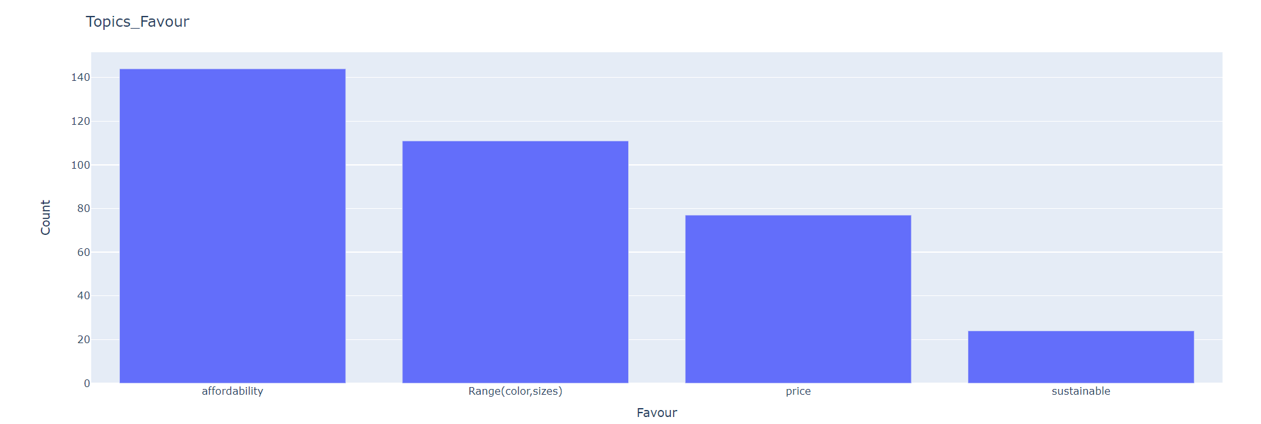

What are the main topics in Canada's comments?

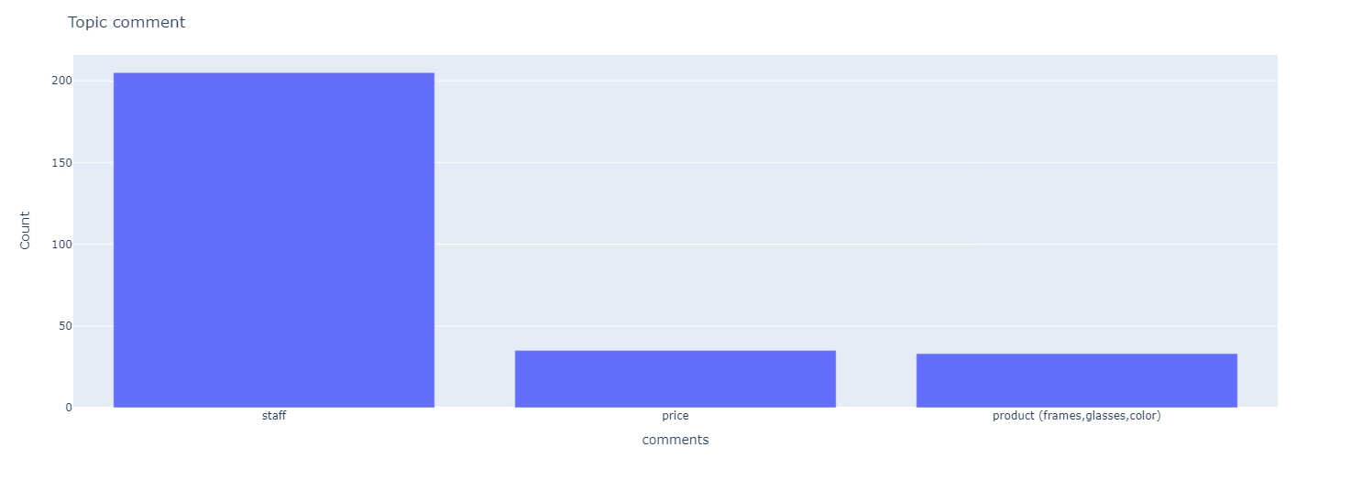

What is the percentage sentiment of each topic from the comment section?

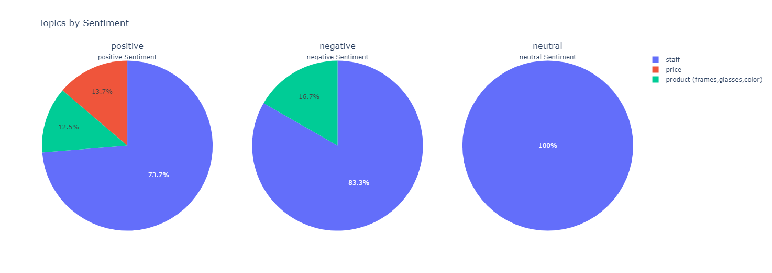

What are the main ways people are finding Dresden in Canada?

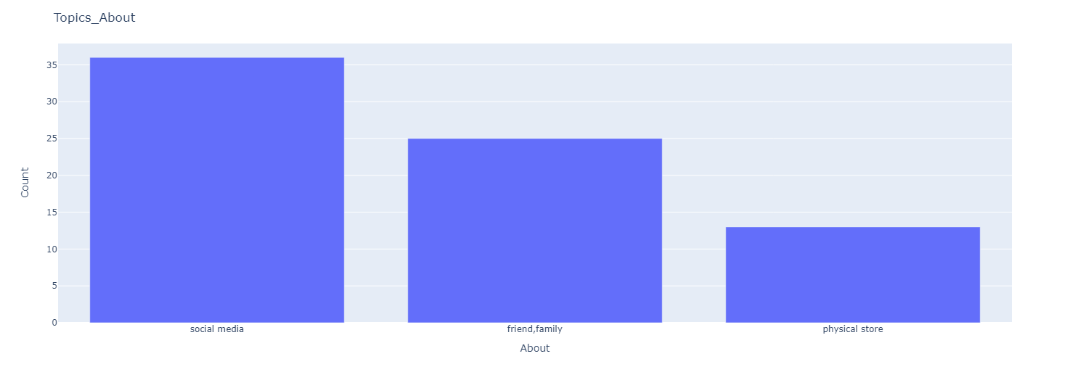

What are the main topics based on each level of recommendation?
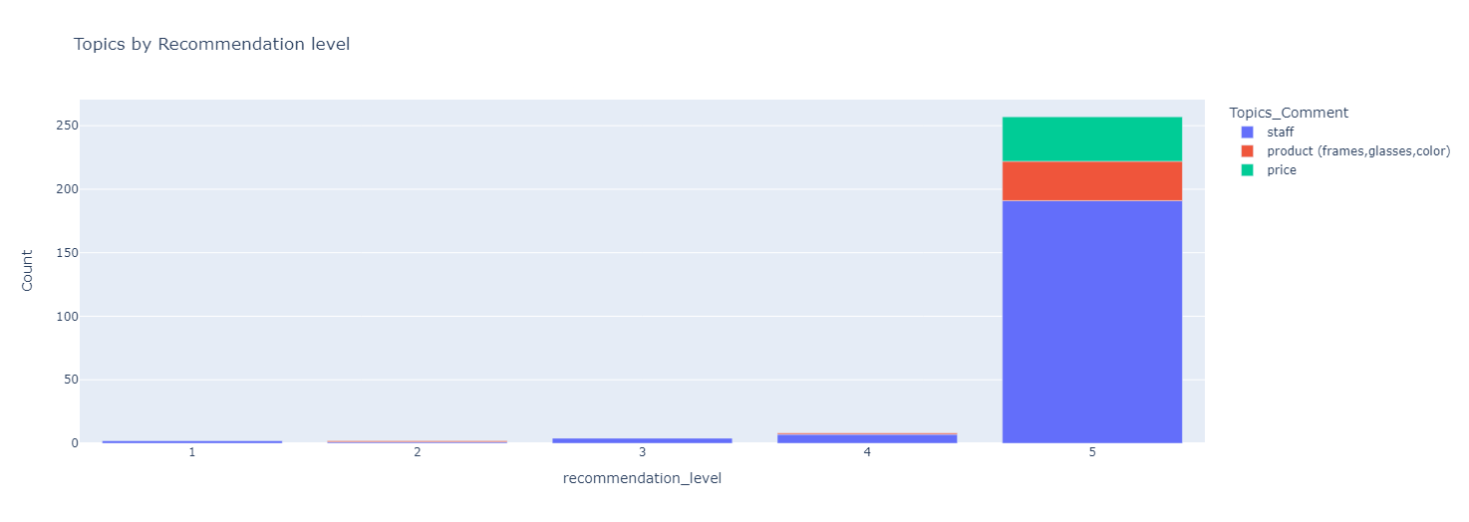

What are the main topics based on each level of satisfaction?
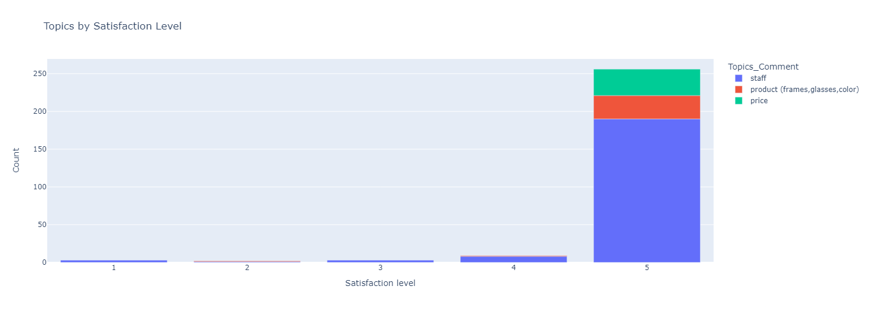

NEW ZEALAND

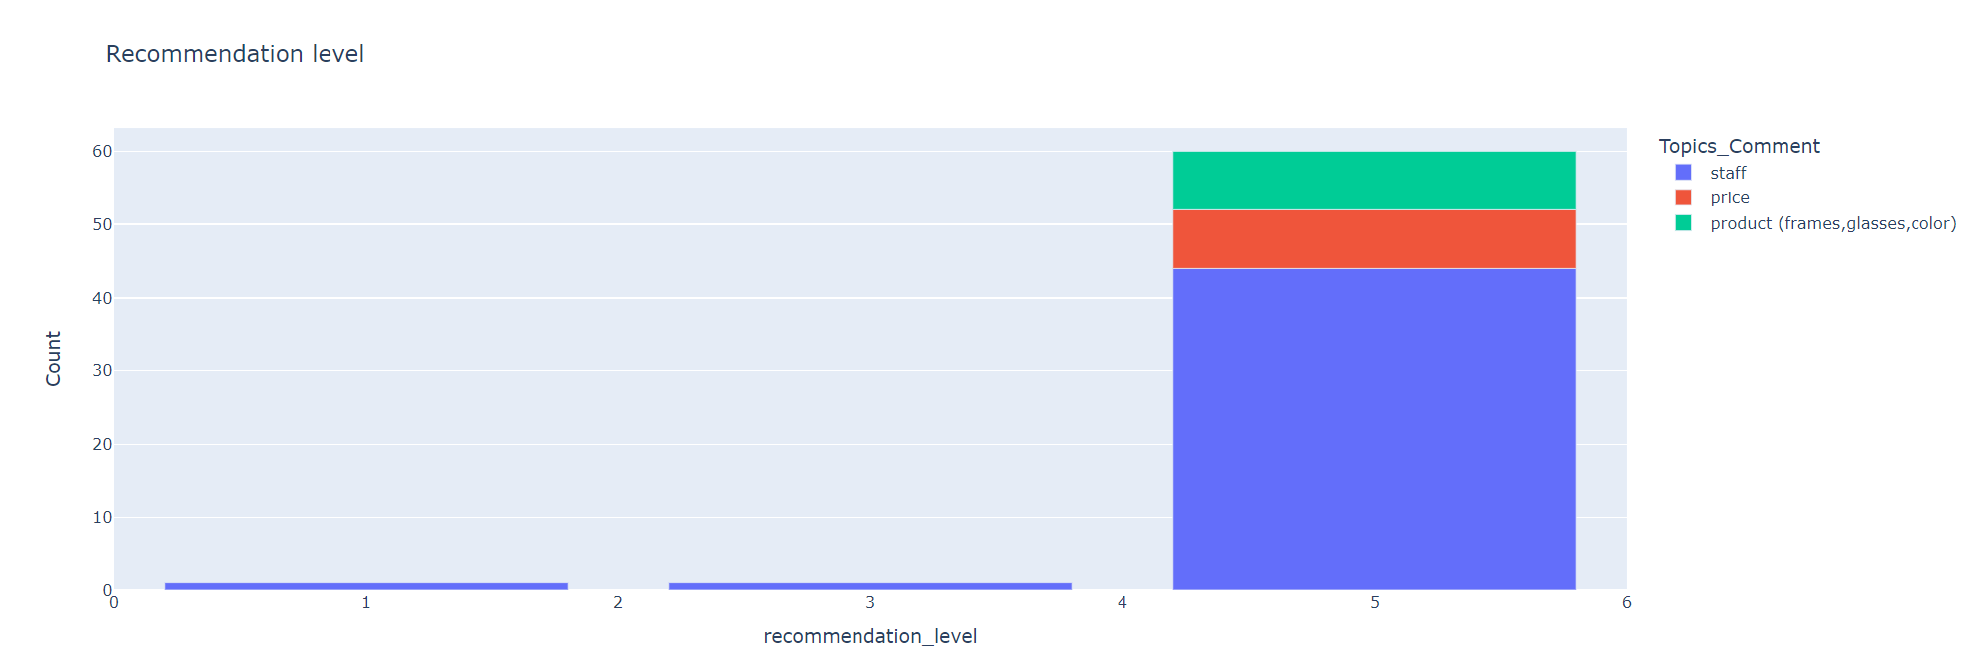
What are the main topics in each level of recommendation?
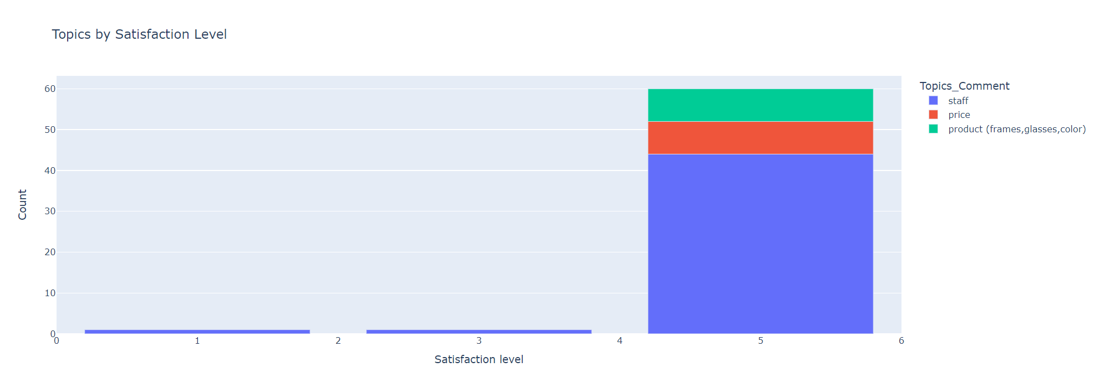

What is the contribution to the sentiment of each topic?

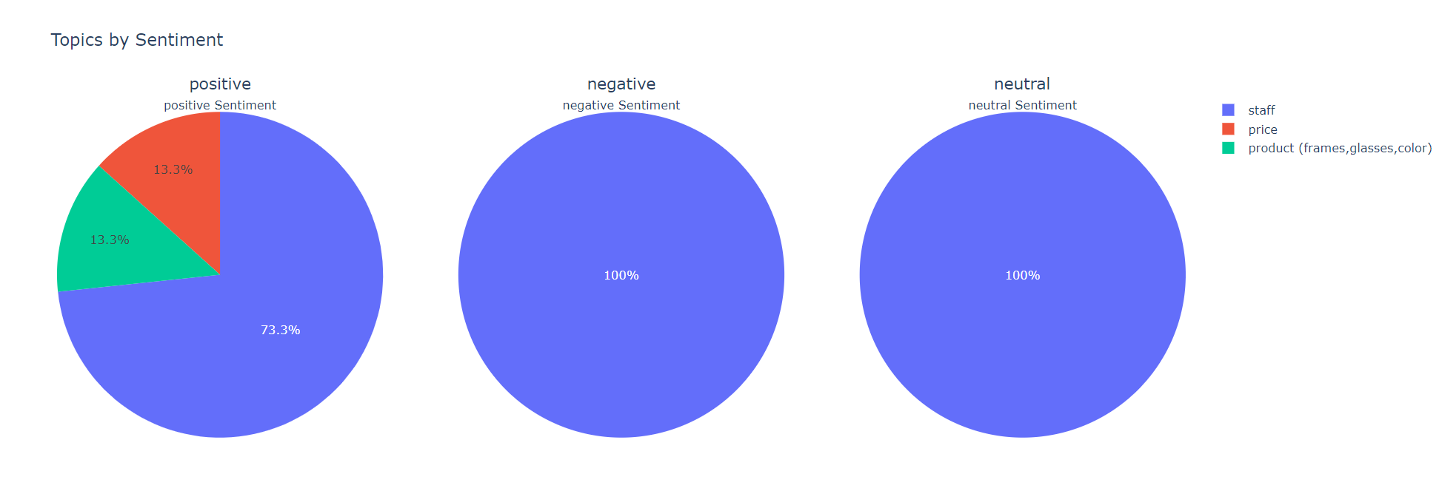

What are the main topics discussed in new zealand?

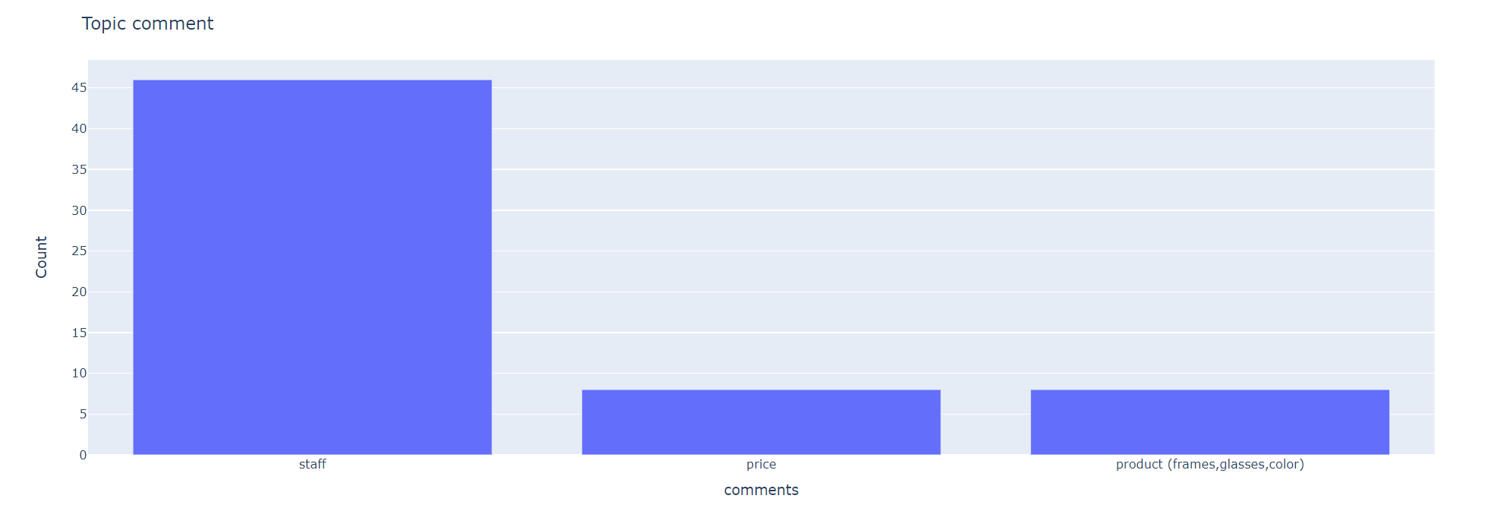

DISCUSSION
In this section, we will talk in-depth about the finding and further techniques used in order to get even more insights from the data. The major aim of the project is to see where we are performing well in terms of the customers as in sentiments and see where we are not doing so well, in that case, we will look deeper into the negative and positive comments and see what exactly are the customers complaining about the most.

Top most appearing words in negative comments
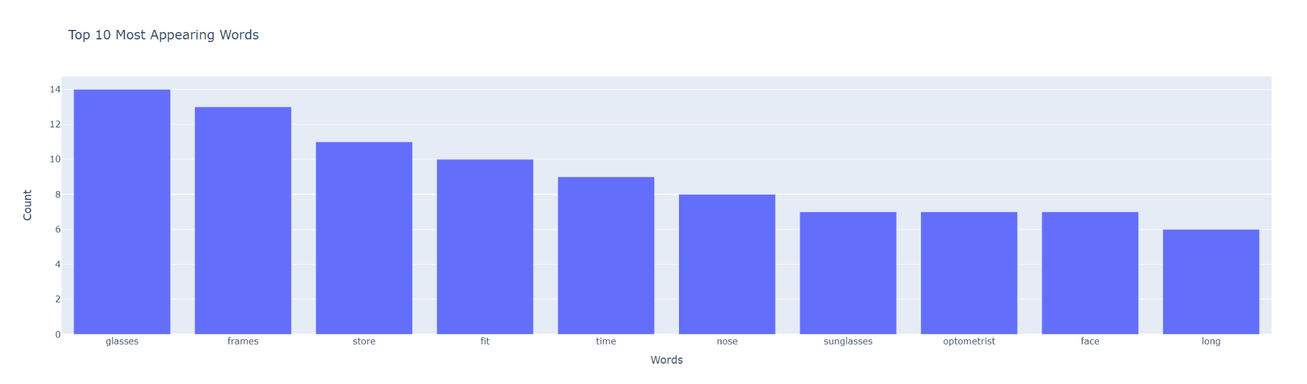
1. "glasses" - 14 occurrences
2. "frames" - 13 occurrences
3. "store" - 11 occurrences
4. "fit" - 10 occurrences
5. "time" - 9 occurrences
6. "nose" - 8 occurrences
7. "sunglasses" - 7 occurrences
8. "optometrist" - 7 occurrences
9. "face" - 7 occurrences
10. "Long" - 6 occurrences

Top most appearing words in Positive comments
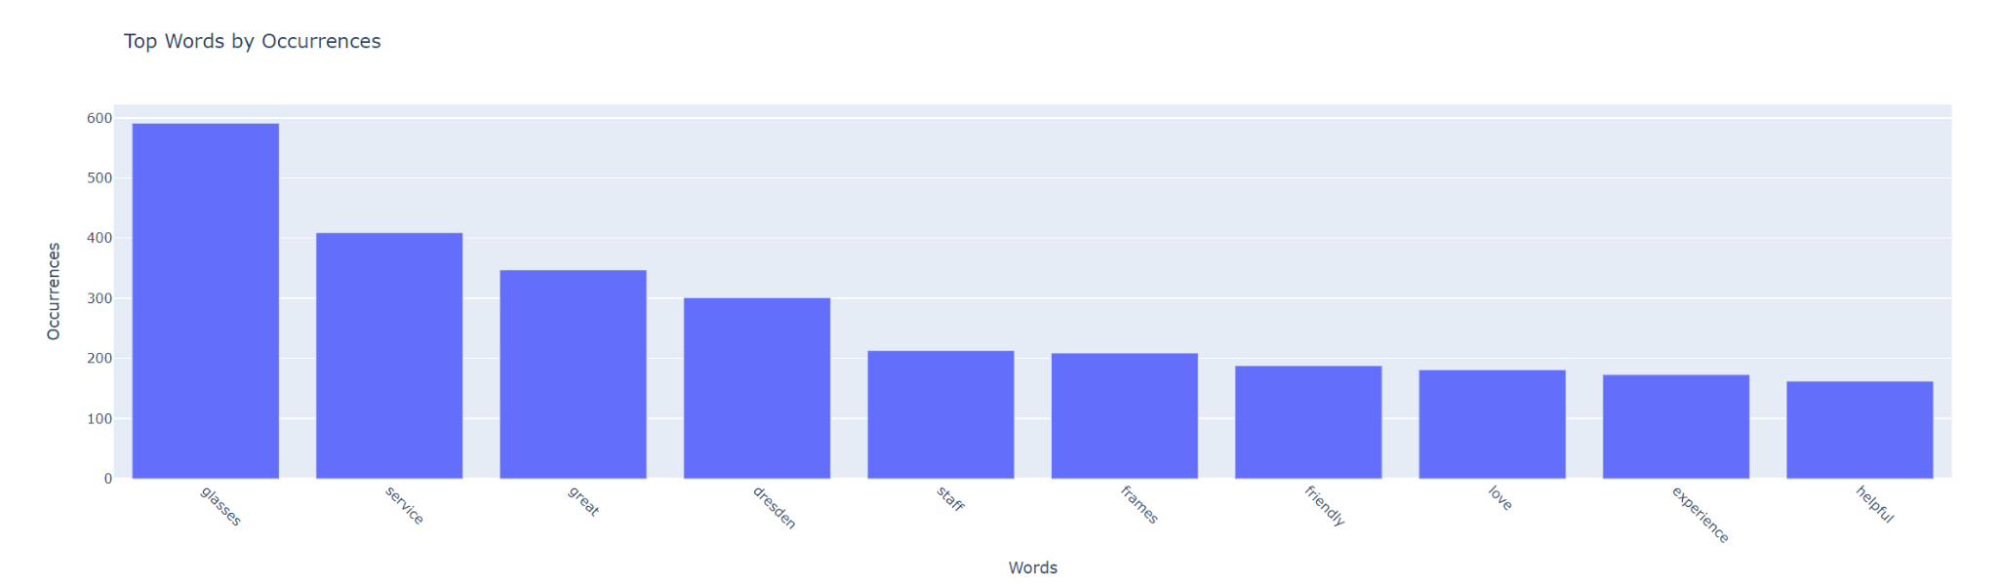
1. “glasses”: 591
2. “service”: 409
3. “great”: 347
4. “Dresden”: 301
5. “staff”: 213
6. “frames”: 209
7. “friendly”: 188
8. “love”: 181
9. “experience”: 173
10. “helpful”: 162

Negative comments
In order to get more thorough and extended research into this aspect. I looked at all negative comments in a general sense and then I discovered some of the most frequent complaints looked like they include:
- Delivery time
- Customer service (especially the attitude of staff and slow response time, moreover, a lot of complaints were also directed towards lack of knowledge of some staff. It seems the quality of instore staff members has depleted as I saw from some of the customers)
- Customers generally seem not to be fully aware of how Dresden works with full functionality
- Customers also expressed dismay at the excessive emails
- Although a lot of customers love the design of the glasses, it seems the functional design is also a big problem to others including sizes, thickness, and loose arms.
- A lot of the customers got wrong delivery or badly received orders which brings dismay to them.

INTEGER OPTIMIZATION USING GUROBI
We can conclude a large amount of the problems faced by customers revolve around customer service which means it is a priority for us, product functionality is also a major issue, and then the price is the third issue
The aim of this project is to optimize customer satisfaction under certain conditions
- customer service(with a weight of 5) (x1 and x2)
- product(with a weight of 4)
- price(with a weight of 2)

consider the following contains
- we have a maximum budget we can invest into this as 10,000 dollars
- change the staff will cost 2000 dollars to recruit a better staff 2) we also have the choice of retraining staff which will cost 5000 dollars 3) customer service and delivery considering the time it will take hence we can take only one choice here
- 1) product lenses 2) product frames 2) product colors (x3, x4, x5) We can only select 2 of these areas
- we can only decrease the price by as much as 200 dollars and as low as 70 dollars(x6) , increase in price will allow more revene for improvement
Note: these can all be edited to suit numerous situations
In this case scenario, we got that focusing on customer service is better for optimization and a price of 87.3 dollars. Not focusing on frames was the best option here

Recommendations
Dresden is a company with a lot of happy customers who love the brand and what it represents to them, however among all the positive comments if we look at the negative comments we can see possible areas of improvement which we can work on. These improvements were insights gotten from analysis as well as direct suggestions from customers

- The surveys should have a more direct and structured approach which is geared directly towards a certain goal from the customers.
- We can assert that the customers are very fond of the discounts however it seems some find the email marketing a bit overwhelming i believe a reevaluation of this would be a good idea moving forward.
- Some customers seem to be unaware of the way the Dresden glasses work hence a suggestion from the comments was a brochure or more information on exactly how to use the glasses, prices, and replace the frames or lenses moreover customers also asked for a color swatch to be more aware of the colors available.
- Customers asked a lot about ranges in frame sizes that would fit more people, having multiple frame designs and sizes would suffice.
- Customer service is a big issue faced in most of the negative comments as they suffered from staff being rude or not knowing the basics and at times staff making big mistakes that leave the customers upset a reevaluation of staff would be good.
- Delivery time is a very big issue for customers as well as a lot of them receive their product a lot later than they should have, providing a form of compensation would be helpful.
- Response time to issues, the customers also had an issue from the lack of response to problems they faced, making a system that is more responsive would be helpful

7. Limitations and Future Work
The Project was a success and we were able to get a comprehensive understanding of the data and how we can optimize customer experience moving forward after we prioritized the more imminent problems in case scenarios, however, we did face some form of drawbacks to our research this includes the better structuring of survey questions to be able to bring draw more feelings from the customers moreover we will also like to look for ways to make sure more customers fill the survey properly by giving a form of encouragement that as well can be of good use in making future projects more successful.

8. Conclusion
The project "Leveraging Sentiment Analysis for Maximizing Customer Satisfaction: An Industrial Engineering Approach" focuses on enhancing customer satisfaction at Dresden Optics, an eyeglass and eye prescription company. By analyzing customer feedback, the project aims to optimize resources to improve overall customer satisfaction.
The study starts with a literature review emphasizing the significance of well-structured surveys to capture customer sentiments effectively. Incorporating an industrial engineering twist, the project develops an integer optimization model to prioritize topics for maximum customer satisfaction. The methodology covers problem identification, data collection, preprocessing, exploratory data analysis, sentiment analysis, topic classification, and optimization.
Data collected from surveys and Google reviews undergoes thorough preprocessing. Exploratory data analysis unveils insights such as primary customer audiences and sources of discovery. Sentiment analysis quantifies customer sentiment, while topic classification delves into discussed themes. The optimization phase allocates resources to topics to systematically enhance satisfaction.
Detailed analyses for overall, Australia, Canada, and New Zealand segments reveal reasons for customer choice, sentiment distribution, recommendation patterns, and more. The study highlights positive and negative sentiments, uncovering common concerns like product functionality, customer service, and pricing.

keywords
1. Sentiment Analysis: Analyzing text to determine the emotional tone or sentiment expressed, such as positive, negative, or neutral, to gauge people's attitudes and opinions.
2. Industrial Engineering: Applying engineering principles to optimize processes, systems, and resources in various industries to enhance efficiency and effectiveness.
3. Customer Satisfaction: The degree of contentment a customer experiences with a product, service, or interaction, often influencing loyalty and future behavior.
4. Optimization: The process of finding the best solution or outcome from a set of possible alternatives, considering various constraints and objectives.
5. Eyeglass Industry: The sector involved in designing, manufacturing, and selling eyeglasses, frames, and lenses for vision correction and fashion purposes.
6. Customer Feedback: Comments, opinions, and evaluations provided by customers about their experiences with products or services.
7. Resource Allocation: Efficiently distributing available resources, such as time, money, and personnel, to achieve desired goals and outcomes.
8. Integer Optimization: a mathematical technique that solves problems where decision variables are required to take integer values, often used in decision-making processes.
9. Data Preprocessing: Cleaning, transforming, and organizing raw data to ensure accuracy and consistency before analysis.
10. Exploratory Data Analysis: Analyzing data sets to summarize main characteristics, identify patterns, and discover potential insights.
11. Topic Classification: Categorizing text data into specific topics or themes using natural language processing techniques.
12. Survey Design: Creating structured questionnaires to collect specific information from respondents, ensuring clear and meaningful data collection.
13. Product Functionality: The ability of a product to perform its intended tasks or functions effectively.
14. Customer Service: The support and assistance provided to customers before, during, and after a purchase or interaction.
15. Pricing Strategy: The approach used to set prices for products or services, considering factors such as costs, competition, and customer value.
16. Recommendation Patterns: Trends or tendencies observed in customers' likelihood to recommend a product or service to others.
17. Resource Optimization: Maximizing the use of available resources while minimizing waste to achieve optimal results.
18. Business Operations: The day-to-day activities and processes involved in running a business, including production, sales, and customer interactions.
19. Actionable Insights: Meaningful and practical information derived from data analysis that can guide informed decision-making and lead to positive outcomes.
20. Survey Analysis: Examining and interpreting survey responses to draw conclusions, identify trends, and extract valuable information.

